TITLE OF SUBMISSION
Author's Name(s)¹, Author's Name(s)², Author's Name(s)³
¹Author Affiliation(s), ²Author Affiliation(s), ³Author Affiliation(s),
COUNTRY.
¹E-mail(s), ²E-mail(s)
ABSTRACT
The abstract is to be in fully-justified italicized text, at the top of column as it is here, below the author information. Use the word “Abstract” as the title, in 12-point Times, boldface type, centered relative to the column, capitalized. The abstract is to be in 11-point, single-spaced type, and up to 250-300 words in length.
Keywords: APA, Qualitative, Quantitative, Research, Academia [4-5 key words or phrases should be included.]

INTRODUCTION
These guidelines include complete descriptions of the fonts, spacing, and related information for producing your proceedings manuscripts. Please follow guidelines and email your paper to editor@ajssh.leena-luna.co.jp
The articles need to be not published elsewhere previously. If the article has been presented at any seminar or conference, the name of the conference, the institution where it has been presented and the date of the presentation needs to be mentioned. The Journal is written in English. Thus, the articles need to be written in this language.
The title of the article must be written in capital letters, using font size 14 and bold. One line space must be left after the title. The name and surname of the author(s), their title, and the institution they work for and its email or web site must be written font size 11 in upper or lower case as mentioned.
The number of the pages of the article must not exceed 20, including abstract and reference list. The whole work must be written in Times New Roman, font size 12. Subheading must be in bold, and the first letter of each word should be in capital letters.

HEADING 1 – MAIN HEADING LEVEL

Heading 2 – Subheading

Heading 3 – Subheading

Heading 4 – Subheading
All the text must be written using single line spacing, including the reference list. The article should normally consist of the following parts: introduction, context and review of literature, method, findings, discussion and conclusion.
All inserts, figures, diagrams, photographs and tables must be centre-aligned, clear and appropriate for black/white, grayscale or colored reproduction.
In tables font size 11 must be used and vertical lines must be not be drawn. When the contents of the table cannot fit into the table, font size 10 might be used. Number of the table and the title should be written above the table. Tables (eg, Table 1) are also numbered consecutively, 1, 2, etc., from start to finish of the paper, ignoring sections and subsections, and independently from figures.
Table 1. Xxxxx xx xxxxx xxxxxx
 | Xxxx | Xxxx | Xxxx
Xxxx Sxxx | xxx | xxx | xx.x %
Xxxx Sxxx | xxx | xxx | xx.x %
Xxxx Sxxx | xxx | xxx | xx.x %
Xxxx Sxxx | xxx | xxx | xx.x %
The items on the reference list must be arranged according to APA Referencing. (Publication Manual of the American Psychological Association). Go to http://owl.english.purdue.edu/ owl/resource/560/01 for more information.
Figures (eg, Figure 1) must be numbered consecutively, 1, 2, etc., from start to finish of the paper, ignoring sections and subsections.
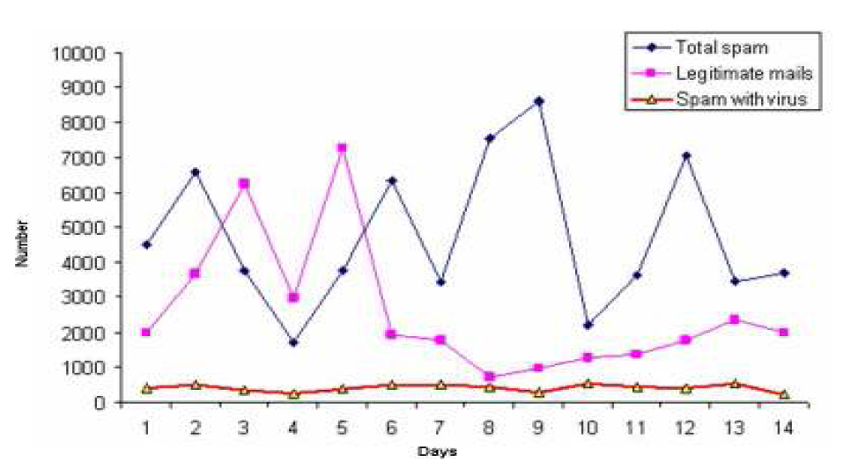
Figure 1. Xxxx xxxx xxxx xxx xxxxxx
All figures, tables, etc. must have a caption, centre-justified in 11 pt. Times New Roman. Captions precede tables but follow figures. Tables and figures should appear as close to their point of reference as satisfactory formatting of the final document permits.
In-Text citations
Use the name of the author(s) followed by the year of publication when citing references within the text and page number. For example:
1 authors (Callan, 1998), 2 authors (Eggen and Kauchak, 2001), 3 or more authors (Levine et al., 2002)

ACKNOWLEDGEMENTS
An (unnumbered) acknowledgements section may be inserted if required.

REFERENCES
List and number all bibliographical references in 12-point Times, single-spaced, at the end of your paper in APA style. All in-text references must be included in list of references.
How to create a reference list?
Single author:
Feldman, R. S. (1996). Understanding Psychology. Newyork: McGraw-Hill,Inc.
Calapkulu, C. (2011). The Framework of “Uses and Gratıfıcatıons Approach” the Televısıon Vıewıng Purpose of Chıldren in the 3-6 Age Group. Academic Research International,1(1), 20-42.
2 authors:
Eggen, P. & Kauchak, D. (2001). Educational Psychology: Windows on Classrooms. New Jersey: Merrill.
Erden, M. & Akman, Y. (1996). Egitim Psikolojisi (Educational Psychology). Ankara: Arkadas Yayınevi.
3 or more authors:
Levine et al., (2002). Signal Analysis of Behavioral and Molecular Cycles. BMC Neuroscience, 3: 1-25.

GUIDELINES FOR AUTHORS
Asian Journal of Social Sciences and Humanities (AJSSH) is an international, professional, and peer reviewed journal. It is regularly published quarterly (February, May, August, November) in English by Leena and Luna International (Pvt) Limited, Chikusei-shi, Japan.
Authors are requested to observe the following guidelines before submission of manuscript:
1. Submission of an article implies that the work described has not been published previously (except in the form of an abstract, working paper, or as part of a published lecture or academic thesis), that it is not under consideration for publication elsewhere, that its publication is approved by all authors and tacitly or explicitly by the responsible authorities where the work was carried out, and that, if accepted, it will not be published elsewhere in the same form, in English or in any other language, without the written consent of the publisher as copyright holder.
2. This journal offers the option of making your article freely available to all by publisher. Authors of the articles being accepted with clear understanding that copyrights are transferred to ‘Leena and Luna International (LL Int.)’ as publisher. You retain many rights as an author, including the right to post a revised personal version of your article on your own website.
3. The publication fee is USD150 for article with maximum 4000 words. Fee for each additional word is 0.05USD. Publication fee excludes taxes and other potential fees such as transfer charges.
Authors will download copies of the journal available online free of cost with open access to everyone, while the print version of journal will be delivered on payment of 50 USD. Prices include airmail cost. If you need print version of journal you have to pay.
4. Please write your text in good English (American or British usage is accepted, but not a mixture of these.
5. Submission to this journal proceeds in word file as email attachment to editor. Word file which is used in the peer-review process. Please note that after the review process, these source files are needed for further processing. All correspondence, including notification of the Editor's decision and requests for revision, takes place by e-mail removing the need for a paper trail.
6. It is important that the file be saved in the native format of the word software. The text should be in single-column format. Keep the layout of the text as simple as possible. Most formatting codes will be removed and replaced on processing the article. In particular, do not use the word software options to hyphenate words. However, do use bold face, italics, subscripts, superscripts etc. When preparing tables, if you are using a table grid, use only one grid for each individual table and not a grid for each row. If no grid is used, use tabs, not spaces, to align columns. The electronic text should be prepared in a way very similar to that of conventional manuscripts. Note that source files of figures, tables and text graphics will be required whether or not you embed your figures in the text. See also the section on Electronic artwork.
7. To avoid unnecessary errors you are strongly advised to use the 'spell-check' and 'grammar-check' functions of your word software. Authors' Template files are available on Webpage of journal.
8. Title may be concise and informative. Titles are often used in information-retrieval systems. Avoid abbreviations and formulae where possible. Author names and affiliations may be included. Where the family name may be ambiguous (e.g., a double name), please indicate this clearly. Present the authors' affiliation addresses below the names. Indicate all affiliations with a lower-case superscript letter immediately after the author's name including the country name, and, the e-mail address of each author.
9. A concise abstract of 250-300 words is required. Immediately after the abstract, provide a maximum of 3-6 keywords. These keywords will be used for indexing purposes. Define abbreviations that are not standard in this field in a footnote to be placed on the first page of the article. Such abbreviations that are unavoidable in the abstract must be defined at their first mention there, as well as in the footnote. Ensure consistency of abbreviations throughout the article.
10. Acknowledgments may be included in a separate section at the end of the article before the references. List here those individuals or organization(s) who provided help during the research (e.g., finances, provided language help, or proof reading the article, etc.)
11. Please note because of technical complications which can arise by converting color figures to 'gray scale' (for the printed version should you not opt for color in print) please submit in addition usable black and white versions of all the color illustrations.
12. Number tables consecutively in accordance with their appearance in the text. Place footnotes to tables below the table body and indicate them with superscript lowercase letters. Avoid vertical rules. Be sparing in the use of tables and ensure that the data presented in tables do not duplicate results described elsewhere in the article.
13. Please ensure that every reference cited in the text is also present in the reference list (and vice versa). Any references cited in the abstract must be given in full. Unpublished results and personal communications are not recommended in the reference list, but may be mentioned in the text. If these references are included in the reference list they should follow the standard reference style of the journal and should include a substitution of the publication date with either 'Unpublished results' or 'Personal communication'. Citation of a reference as 'in press' implies that the item has been accepted for publication.
14. For web references, as a minimum, the full URL should be given and the date when the reference was last accessed. Any further information, if known (DOI, author names, dates, reference to a source publication, etc.), should also be given. Web references may be listed separately at end of the reference list under a different heading, or can be included in the reference list.
15. Citations in the text should follow the referencing style used by the American Psychological Association. You are referred to the Publication Manual of the American Psychological Association, Sixth Edition, ISBN 978-1-4338-0561-5, copies of which may be ordered from APA Order Dept., P.O.B. 2710, Hyattsville, MD 20784, USA or http://books.apa.org/books.cfm?id=4200067 or Details concerning this referencing style can also be found at http://linguistics.byu.edu/faculty/henrichsenl/apa/apa01.html.
16. References should be arranged first alphabetically and then further sorted chronologically if necessary. More than one reference from the same author(s) in the same year must be identified by the letters 'a', 'b', 'c', etc., placed after the year of publication.
Examples:
Reference to a journal publication:
Van der Geer, J., Hanraads, J. A. J., & Lupton, R. A. (2010). The art of writing a scientific article. Journal of Scientific Communications, 163, 51–59.
Reference to a book:
Strunk, W., Jr., & White, E. B. (1979). The elements of style. (4th ed.). New York: Longman, (Chapter4).
Reference to a chapter in an edited book:
Mettam, G. R., & Adams, L. B. (2009). How to prepare an electronic version of your article. In B. S. Jones, & R. Z. Smith (Eds.), Introduction to the electronic age (pp. 281–304). New York: E-Publishing Inc.
17. The following list will be useful during the final checking of an article prior to sending it to the journal for review. Please consult these guidelines for authors for further details of any item. Please ensure that the following items are present, and all necessary part of article/files have been included, and contain : a) One author has been designated as principal or the corresponding author with contact details: E-mail address, full affiliation postal address, Telephone and fax numbers, b) Keywords, c) All figure captions, d) All tables (including title, description, footnotes, e)Manuscript has been 'spell-checked' and 'grammar-checked', f) References are in the correct format for this journal, g) All references mentioned in the Reference list are cited in the text, and vice versa, h)Permission has been obtained for use of copyrighted material from other sources (including the Web), i) Color figures are clearly marked as being intended for color reproduction on the Web (free of charge) and in print, or to be reproduced in color on the Web (free of charge) and in black-and-white in print, j)If only color on the Web is required, black-and-white versions of the figures are also supplied for printing purposes.
18. In order to increase the exposure of your article, we suggest the following: a) The title of your article must be clear and descriptive, using keywords that are relevant to the subject area, and would most likely be used in an online search, b) The abstract must also contain keywords and common phrases for the subject area. These carefully chosen keywords and phrases can also be emphasized in the text, however please do this with caution as some search engines can reject overly repetitive WebPages.
19. One set of page proofs (as PDF files) will be sent by e-mail to the corresponding author or, a link will be provided in the e-mail so that authors can download the files themselves. LL Int. will provide authors with PDF proofs which can be annotated; for this you will need to download Adobe Reader latest version available free from http://get.adobe.com/reader.
20. Please use this proof only for checking the typesetting, editing, completeness and correctness of the text, tables and figures. Significant changes to the article as accepted for publication will only be considered at this stage with permission from the Editor. We will do everything possible to get your article published quickly and accurately – please let us have all your corrections within 48 hours. It is important to ensure that all corrections are sent back to us in one communication: please check carefully before replying, as inclusion of any subsequent corrections cannot be guaranteed. Proofreading is solely your responsibility. Note that publisher may proceed with the publication of your article if no response is received.
21. Changes to authorship: This policy concerns the addition, deletion, or rearrangement of author names in the authorship of accepted manuscripts:
Before the accepted manuscript is published in an online issue: Requests to add or remove an author, or to rearrange the author names, must be sent to the editor from the principal or corresponding author of the accepted manuscript and must include: (a) the reason the name should be added or removed, or the author names rearranged and (b) written confirmation (e-mail, fax, letter) from all authors that they agree with the addition, removal or rearrangement. In the case of addition or removal of authors, this includes confirmation from the author being added or removed.
22. Requests that are not sent by the principal corresponding author will be forwarded by the Director (Research) to the corresponding author, who must follow the procedure as described above. Note that: (a) Director (Research) will inform the Journal Editors of any such requests and (b) publication of the accepted manuscript in an online issue may be suspended until authorship has been agreed. After the accepted manuscript is published in an online issue, any requests to add, delete, or rearrange author names in an article published in an online issue will follow the same policies as noted above and result in a corrigendum.
23. It is not our policy to pay authors.
24. Copyright: Permission of the Publisher is required for commercial purpose, resale, distribution outside the institution and for all other derivative works, including compilations and translations.
24. Authors are requested to identify who provided financial support for the conduct of the research and/or preparation of the article in study design; in the collection, analysis and interpretation of data; in writing of the report; and in the decision to submit the paper for publication. If the funding source(s) had no such involvement then this should be stated.
25. Authors may submit, with the manuscript, the names and address of up to three potential referees. Whether these referees are contacted remains at the discretion of the editors.
26. For inquiries relating to the submission of articles (including electronic submission) please visit concerned journal’s homepage. Contact details for questions arising after acceptance of an article, especially those relating to proofs, will be provided by the editor.
All manuscripts submitted will be considered for publication. Manuscripts should be sent as an email attachment to editor.assh@leena-luna.co.jp or director.rdllint@gmail.com
For further details, please visit the journal web-page or contact to:
The Editor
Asian Journal of Social Sciences & Humanities
Chikusei-shi, Ibaraki-ken, Japan.
Online ISSN:2186-8492, Print ISSN:2186-8484
URL: http://www. ajssh.leena-luna.co.jp/
Email:editor.ajssh@leena-luna.co.jp
editor.ajssh@gmail.com
director.rdllint@gmail.com

